1. Write an INNER JOIN query to fetch the order_id, customer_name, and product_name for all orders placed on your favorite food delivery app (imagine Swiggy or Zomato) using tables: Orders, Customers, and Products.
Ans;
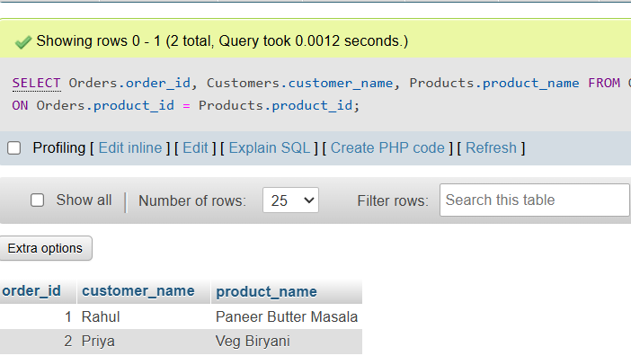

2. Write a LEFT JOIN query to list all users from a Flipkart-style Users table and show their last order date from the Orders table, including users who have never placed an order.<br><br><em><strong>Hint:</strong> Check for NULL values in the order date to identify users with no orders.</em>
Ans:
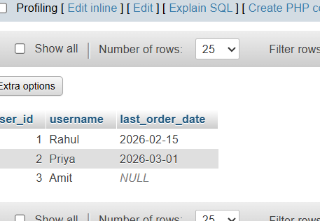

3. Write a RIGHT JOIN query to display all products from a Myntra-style Products table and the name of the user who last bought each product from the Users table, including products that have never been purchased.
Ans:
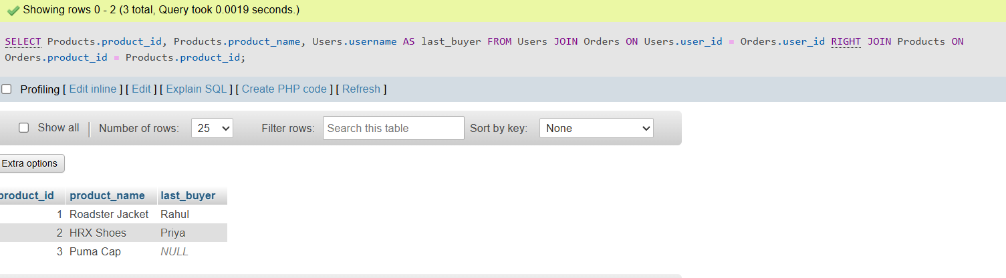

4. Write a FULL JOIN query to combine all payment transactions from a Paytm Payments table and all refund records from a Refunds table, showing transaction_id, amount, and whether it's a payment, refund, or both.
Ans:
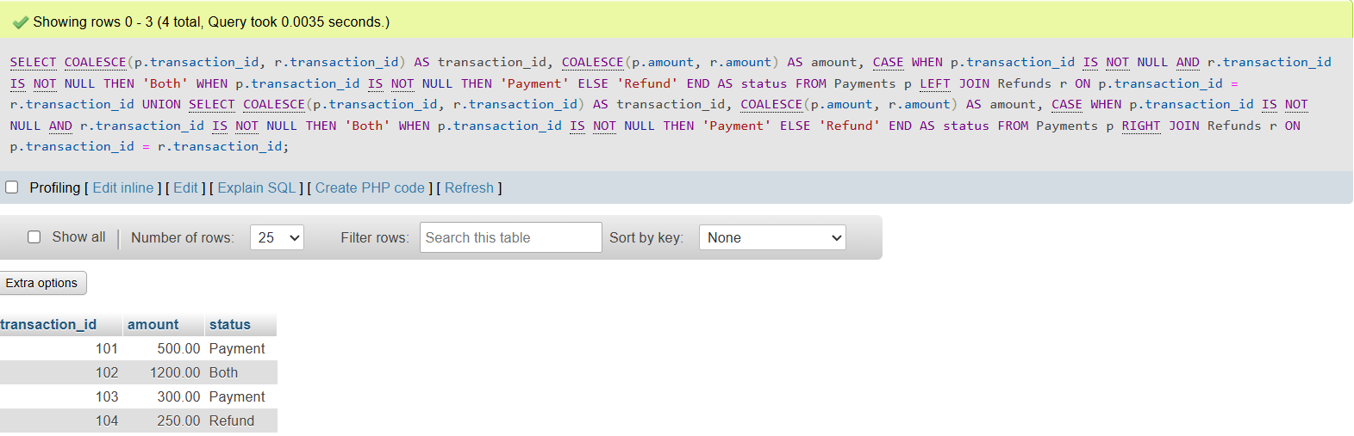

5. Write a SELF JOIN query on a BookMyShow-style Movies table to find all pairs of movies that share the same genre but have different movie_ids.<br><br><em><strong>Constraint:</strong> Do not show pairs where both movies are the same.</em>
Ans:
